1.2 develop a digital technologies outcome
Project Documentation

PURPOSE. END-USERS. REQUIREMENTS
What is the purpose of your outcome? And how does it reflect or promote Kaitiakitanga?
The type of digital media outcome I’m making is a website that educates people on what's in our rivers and how we can protect them. This promotes Kaitiakitanga by educating people on what's in our rivers but also how we can be kaitiaki (guardians) and protect them. A website that encourages people to pick up their rubbish and be guardians.
Describe the users. Who is the audience? What do the people who will use your outcome need?
The target audience for my website is all ages but more directed towards the younger ages around 5-13 years of age and any gender that are from New Zealand/living in NZ. The intended audience are people wanting to learn more about what is in their local river and how they can help protect them. This website could be found on google but my audience will likely be introduced to my website at school or by their guardians if they are part of the younger target audience.
Describe the requirements and specifications. What does your digital technologies outcome need to
have, be, or do in order to achieve its purpose and work best for the people it is intended for?
Since my end users are mainly intended for those in the age range of 5-13 years old my website needs to be simple and be in the users language. To do this I want to be using simple phrases and less complicated scientific words, for the aesthetics I want the site to have fun colours but not too overwhelming for the audience. The website needs to be easy to use with limited buttons so the audience doesn’t get lost or confused. When it comes to my page about kaitiakitanga and what they can do to protect the plants and animals I want it to be simple things that are age appropriate for my targeted audience like picking up rubbish etc. I want it to have some sort of simple game like “Can you find a whitebait”. Must be age appropriate for 5-13 year olds

- Two pages that separate freshwater plants from freshwater animals
- A page that talks about kaitiakitanga and being a kaitiaki (guardian) and what they can do to protect the freshwater life.
- Must have a back to home button that is big enough to see
- Must have visual images of what the plants and animals look like and the maori and english name
- A font that is easy to read
- Language that is familiar to the audience and age appropriate to the audience
- Images need to be optimised 72dpi
- 1920 by 1080 Screen size

MAKE A PLAN
Using Trello make a plan of attack to complete this project
https://trello.com/b/amkI48KF/develop-outcome

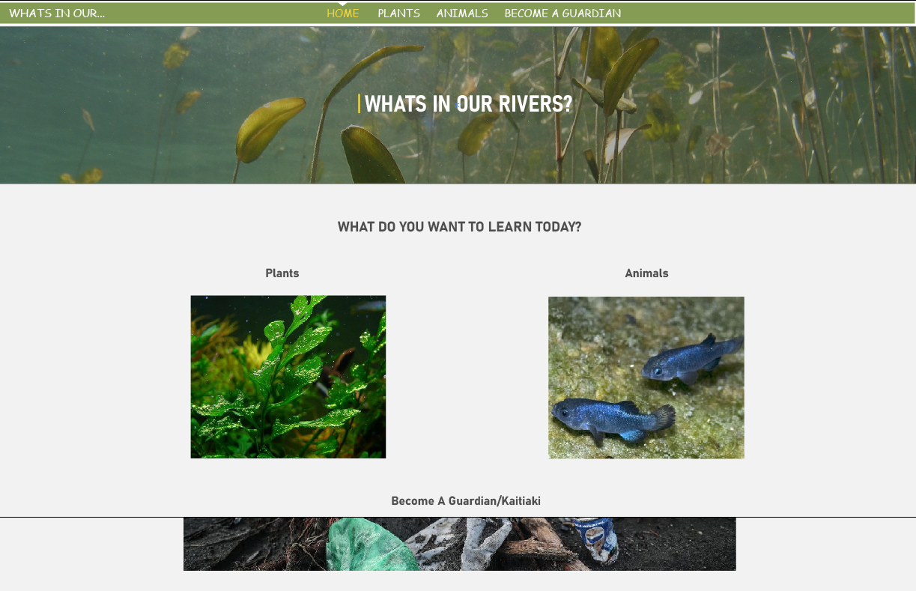 | 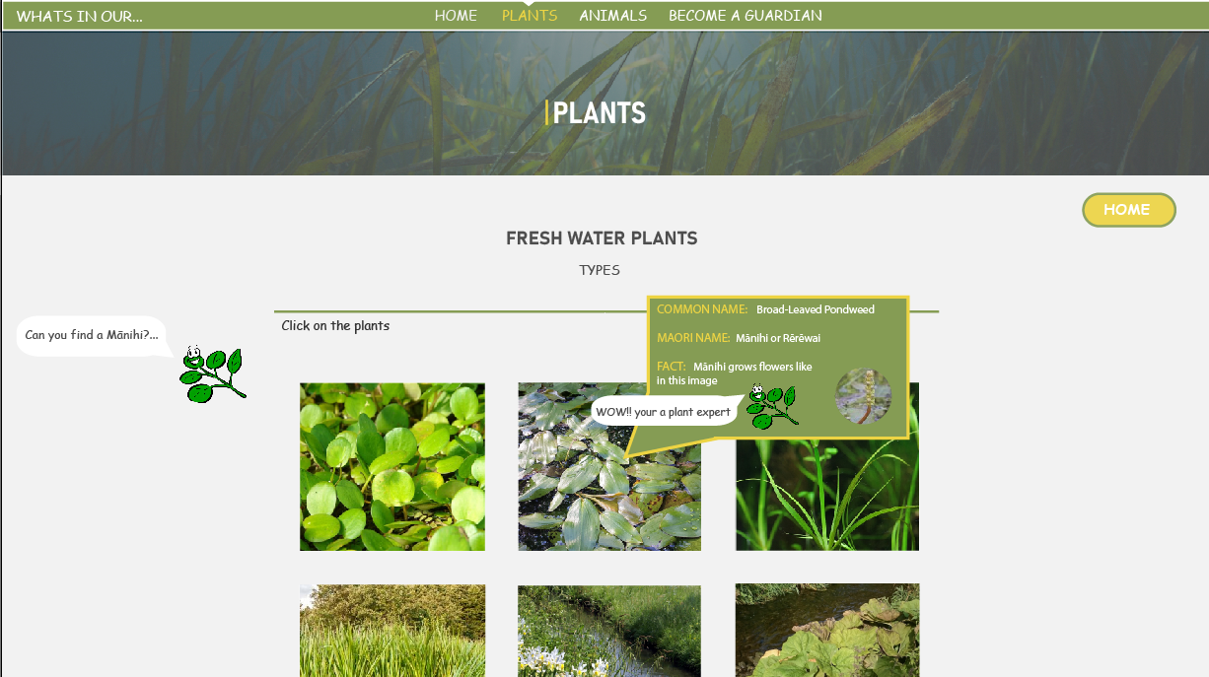
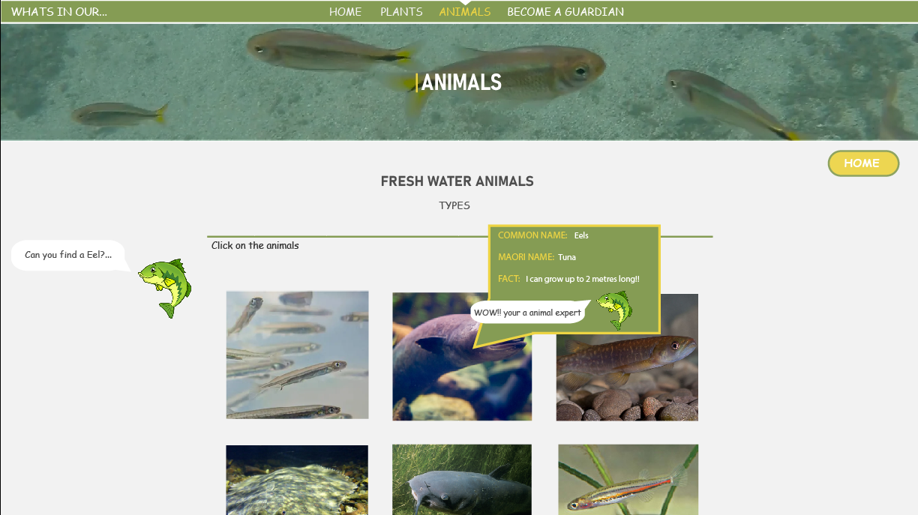 | 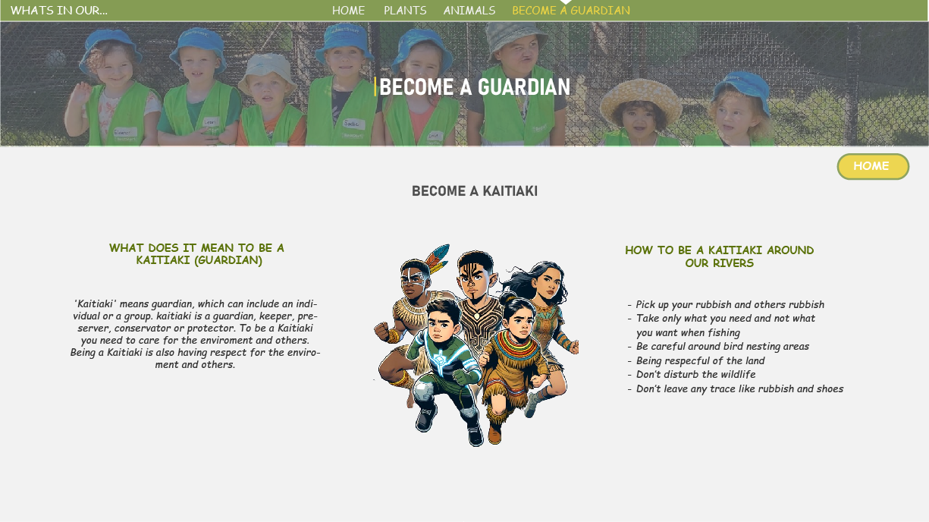

TOOLS AND TECHNIQUES
What tools and techniques did you use during the development of your outcome?
Some tools and techniques I used were things like folder management which meant I had folders for my assets, images, css and an index html page.
Images - optimise, hover effect
Pop up on the images
What do i use the folders for

CONVENTIONS
What conventions did you follow during the development of your outcome?
File name rules
Having the nav bar at the top

TESTING - checking your outcome works as intended
What testing did you do during the development of your outcome?
What improvements did you make as a result of your testing?
How did these changes affect the outcome fitness for purpose?

TRAILING - getting others to use your outcome
What trailing did you do during the development of your outcome?
What improvements did you make as a result of your trailing?
How did these changes affect the outcome fitness for purpose?

FINAL
How can you show the tools and techniques you applied were effective in producing a fit-for purpose outcome?
Final outcome - Screenshot/screencast/link

